ROV Project

7/12/13

I met with Mike and we discussed errors with my Core schematic and he wanted me to research the RS-422 protocol and how to use it.

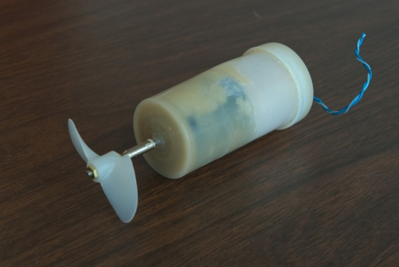7/14/13

I fixed the majority of the issues with the Core schematic and I completely re-wired it, I also removed the components from the breadboard and placed them on the PC board for future mounting, I also thought up an idea for waterproofing the motors with a 1" end cap filled with grease which would act like a stuffing box to keep the water out but to allow the shaft to spin.

Sealed motor with grease. (Not mine)

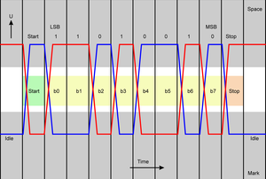7/20/13

I researched the RS-422 protocol a bit and I found that when the positive voltage rises to the top, that writes a 1 bit value and when the negative voltage reaches to the top it writes a 0 bit value, also I noticed that when the two voltages crossed it moved on to the next bit, so maybe this is how it accurately writes binary values without timing errors by resetting when the voltages cross, also if it knows to write a 1 bit when red is high and blue is negatively high, then if one of them are interrupted then it will still know what to write or it would know if there was an error.

7/22/13

Today I re-made the Controls schematic into Rev 1.1, I also created Rev 1.0 of a System Flow Chart of the ROV.

7/23/13

I started to solder together the Core board, I put in all of the headers, constructed the power system and distribution and I was able to get the Indicator board to detect the logic power and the motor power, I also hooked up the controls and the 556 Clock to the Indicator board and the Switchboard and tested to see if they worked and they did.

7/24/13

I connected the Switchboard to the Core along with partially connecting the Motor Inverters, so far I have gotten motors 1 and 2 to function properly but occasionally 556 1 OUT goes high.

7/28/13

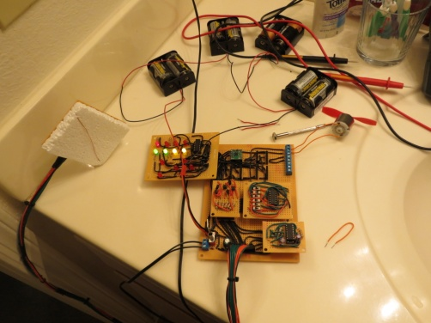I completed the entire electrical control system (Minus camera connections), the 556 1 OUT is still inconsistent, I have built a main motor assembly with a stuffing box but the caulking will take 3 days to dry, when it dries I will test it underwater along with the control system when I make a battery case.

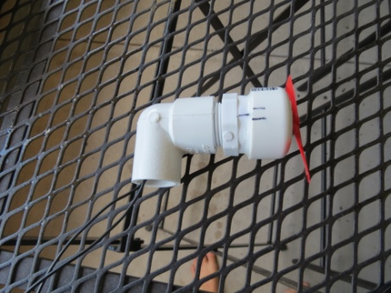

My sealed motor assembly! Entire control system functioning!

7/30/13

I tested the motor assembly in water along with the control system, when I use the battery for the logic and the motors I get constant power variations and the motor is noticeably slower, but when I use AC power for the logic this problem is eliminated.

Using 1 motor controller, the motor draws 1.5A of current at high speed and draws 1A of current at low speed, on high the motor controller starts to overheat 20 seconds in and there are minor output fluctuations, but after 40 seconds the motor is very jittery. On low power the motor ran fine until about 1 minute in and there was an occasional power drop that increased in frequency as time went on.

Using 2 motor controllers there is a noticed power boost and the motor ran until I cut power with no problems on high, when on low there were no power issues as well. When using both controllers the motor drew 1.6A on high and 1.2A on low power.

8/1/13

I Finished the Core V1.3 schematic by finishing the connections to the switchboard.

8/2/13

I drilled and cut the final 2 motor end caps and I completed the other main motor assembly, once it dries I will test it out in water to see if it is really sealed or not.

8/4/13

I started and completed the Indicators schematic and sent Mike an update.